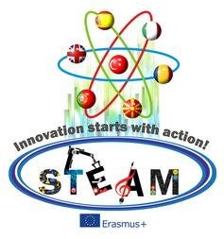

Innovation statrs with action!
STEAM Lesson Plan
School & Country
Teacher | For example Yıldız Kanlıöz –Primary school teacher
Class age of students
Lessons
Themes
Time duration
What will be learn? Which methodology are used for these activities?
- Materials
- Art
- Science
- Technology
- Engineering
- Robotics
- Coding and programming
- ICT and Web 2.0
- Museum Activity
- Nature Activity
- School Activity
- How to measure these activities?
- How Innovative is it?
- Creativity
- Interdisiplinary
- Measurable
- Sustainability
- Applicability
- Collobrative
- Economic in save of time and money

